**VIRTUAL CAAFE**

**(WEB BASED LEARNING SYSTEM)**

**SUBMITTED TO:  
NILKITA KAUSHIK MA’AM**

**MADE BY:**

**KISHAN (11903288)  
VAMSI (11903311)  
SUSHANT (11903319**



VIRTUAL CAFE

SECTION: K19EG

SUBJECT: INTERNET PROGRAMMING LABORATORY(CSE326).

PROJECT TITLE: STUDENT CENTRED LEARNING ONLINE WEBSITE (VIRTUAL CAFE).

|  |  |  |
| --- | --- | --- |
| ROLL NO | NAME | REGISTRATION NUMBER |
| 22 | KISHAN KUMAR SINGH | 11903233 |
| 23 | MIDDULA VAMSI | 11903311 |
| 24 | PAL SUSHANT KALIKAPRASAD | 11903319 |

|  |  |  |
| --- | --- | --- |
| 1 | INTRODUCTION | 4-7  PAGE |
| 2 | OBJECTIVES | 8  PAGE |
| 3 | MODULES | 9  PAGE |
| 4 | SNAPSHOTS | 10-14  PAGE |
| 5 | MY CONTRIBUTIONS | 15-17 |

INTRODUCTION

INTRODUCTION TO WEB BASED STUDENT-CENTRED LEARNING ONLINE WEBSITE (VIRTUAL CAFE).

Introduction of the Project Web based learning System (virtual café). The "Web based learning System (virtual café)" has been developed to override the problems prevailing in the practicing manual system. This project is supported to eliminate and, in some cases, reduce the hardships faced by this existing system. Moreover, this system is designed for the particular need of the company to carry out operations in a smooth and effective manner. The application is reduced as much as possible to avoid errors while entering the data. It also provides error message while entering invalid data. No formal knowledge is needed for the user to use this system. Thus, by this all it proves it is user-friendly. Web based Learning System, as described above, can lead to error free, secure, reliable and fast management system. It can assist the user to concentrate on their other activities rather to concentrate on the record keeping. Thus, it will help organization in better utilization of resources. Every organization, whether big or small, has challenges to overcome and managing the information of Student, Assignment, CLASS, and QUESTION. Every Web based learning Management System has different Assignment needs; therefore, we design exclusive teacher systems that are adapted to your managerial requirements. This is designed to assist in strategic planning, and will help you ensure that your organization is equipped with the right level of information and details for your future goals. Also, for those busy executives who are always on the go, our systems come with remote access features, which will allow you to manage your workforce anytime, at all times. These systems will ultimately allow you to better manage resources.

INTRODUCTION

INTRODUCTION TO WEB BASED STUDENT-CENTRED LEARNING ONLINE WEBSITE (VIRTUAL CAFE).

The purpose of Web based learning System is to automate the existing manual system by the help of computerized equipment’s and full-fledged computer software, fulfilling their needed, requirements, so that their valuable data/information can be stored for a longer period with easy accessing and manipulation of the same. The required software and hardware are easily available and easy to work with. Web based learning Management System, as described above, can lead to error free, secure, reliable and fast management system. It can assist the user to concentrate on their other activities rather to concentrate on the record keeping. Thus, it will help organization in better utilization of resources. The organization can maintain computerized records without redundant entries. That means that one need not be distracted by information that is not relevant, while being able to reach the information.

Functionalities provided by E-learning Management System:

 E-learning Management System also manage the CLASS details online for QUIZ details, QUESTION details, Assignment.

• It tracks all the information of Student, CLASS, and QUIZ etc

• Manage the information of Student. • Shows the information and description of the Assignment, TEACHER

• To increase efficiency of managing the Assignment, Student.

• It deals with monitoring the information and transactions of QUIZ.

INTRODUCTION

INTRODUCTION TO WEB BASED STUDENT-CENTRED LEARNING ONLINE WEBSITE (VIRTUAL CAFE).

 Scope of the project Web based learning Management System:

It may help collecting perfect management in details. In a very short time, the collection will be obvious, simple and sensible. It will help a person to know the management of passed year perfectly and vividly. It also helps in current all works relative to E-learning Management System. It will be also reduced the cost of collecting the management & collection procedure will go on smoothly. Our project aims at Business process automation, i.e. we have tried to computerize various processes of Web based learning System.

• In computer system the person has to fill the various forms & number of copies of the forms can be easily generated at a time.

• In computer system, it is not necessary to create the manifest but we can directly print it, which saves our time.

• To assist the staff in capturing the effort spent on their respective working areas.

• To utilize resources in an efficient manner by increasing their productivity through automation.

INTRODUCTION

INTRODUCTION TO WEB BASED STUDENT-CENTRED LEARNING ONLINE WEBSITE (VIRTUAL CAFE).

 Reports of Web based learning Management System:

• It generates the report on Assignment, Student, and CLASS

• Provide filter reports on TEACHER, QUIZ, and QUESTION

• Modules Web based learning System:

• ASK QUERIES Module: Used for managing the details of QUESTION.

• HOME Module: Used for managing the QUIZ information’s

• STUDENT OR ADMIN Module: Used for managing the login details

• FORGOT PASSWORD module: Used for managing the forgot users of the system.

• IAS, IES, GATE PREP module: Used for managing entrance exam preparations.

• PRIVACY module: To know the rights of our website.

• FACEBOOK module: To be connected with social websites.

OBJECTIVES

OBJECTIVES OF WEB BASED STUDENT-CENTRED LEARNING ONLINE WEBSITE (VIRTUAL CAFE).

The main objective behind this project is to provide a user-friendly environment to provide knowledge and give everyone a chance to learn, irrespective of where they are, provided they register themselves with the system.

The main features that the system provides can be made use of, once the registered people select their interested subject and take a starter test.

This helps to establish incremental learning process. After taking this, based on their level of competence, they can take available tutorials, take online tests and also discuss an issue/topic by posting messages in the discussion forum.

Along with this they can also take real time simulations of the most widely known competitive exams. Project on E-learning Management System is to manage the details of Assignment, Student, TEACHER, QUESTION.

It manages all the information about Assignment, CLASS, QUESTION, Assignment. The project is totally built at administrative end and thus only the administrator is guaranteed the access. The purpose of the project is to build an application program to reduce the manual work for managing the Assignment, Student, CLASS, TEACHER. It tracks all the details about the TEACHER, QUESTION.

MODULES

MODULES OF WEB BASED STUDENT-CENTRED LEARNING ONLINE WEBSITE (VIRTUAL CAFE).

Description:

Online Education website is to provide services to students who are in need of proper educator for their subjects by getting help from the educator that are available to them. There are nine modules in this system.

STUDENT OR ADMIN LOGIN:

In this section, a user can login to his account with the help of user Id and password to share and update information like age, location, last learning hours, contact number and he/she can post their queries.in this user can login as Admin, teacher, student.

SIGN UP:

In this module user who login’s have to first registered on our website and give his/her overall details related to him i.e. he fills in a registration such as contact number, email address etc and after that they can login to our website.

ASK QUERIES:

In this module user can ask their doubts to the educators and clear their queries after the completion of each and every topic.

IAS, IES, GATE PREPRATION:

In this module students will be able to choose for what exams are they preparing like entrance, government exams and engineering exams like GATE. In this module you can select the exam for which you want to prepare in that you can select test, exam, and test preparation.

CONTACT US:

Through the contact section students can communicate with virtual cafe admin panel if they are facing any problem with their account

PRIVACY:

It guides the user about the rights and terms and conditions related to web-based learning system.

FACEBOOK:

It guides the user about our connection with social sites and our social family.

______________________________________________________________________________

SNAPSHOTS

SNAPSHOTS OF WEB BASED LEARNING SYSTEM

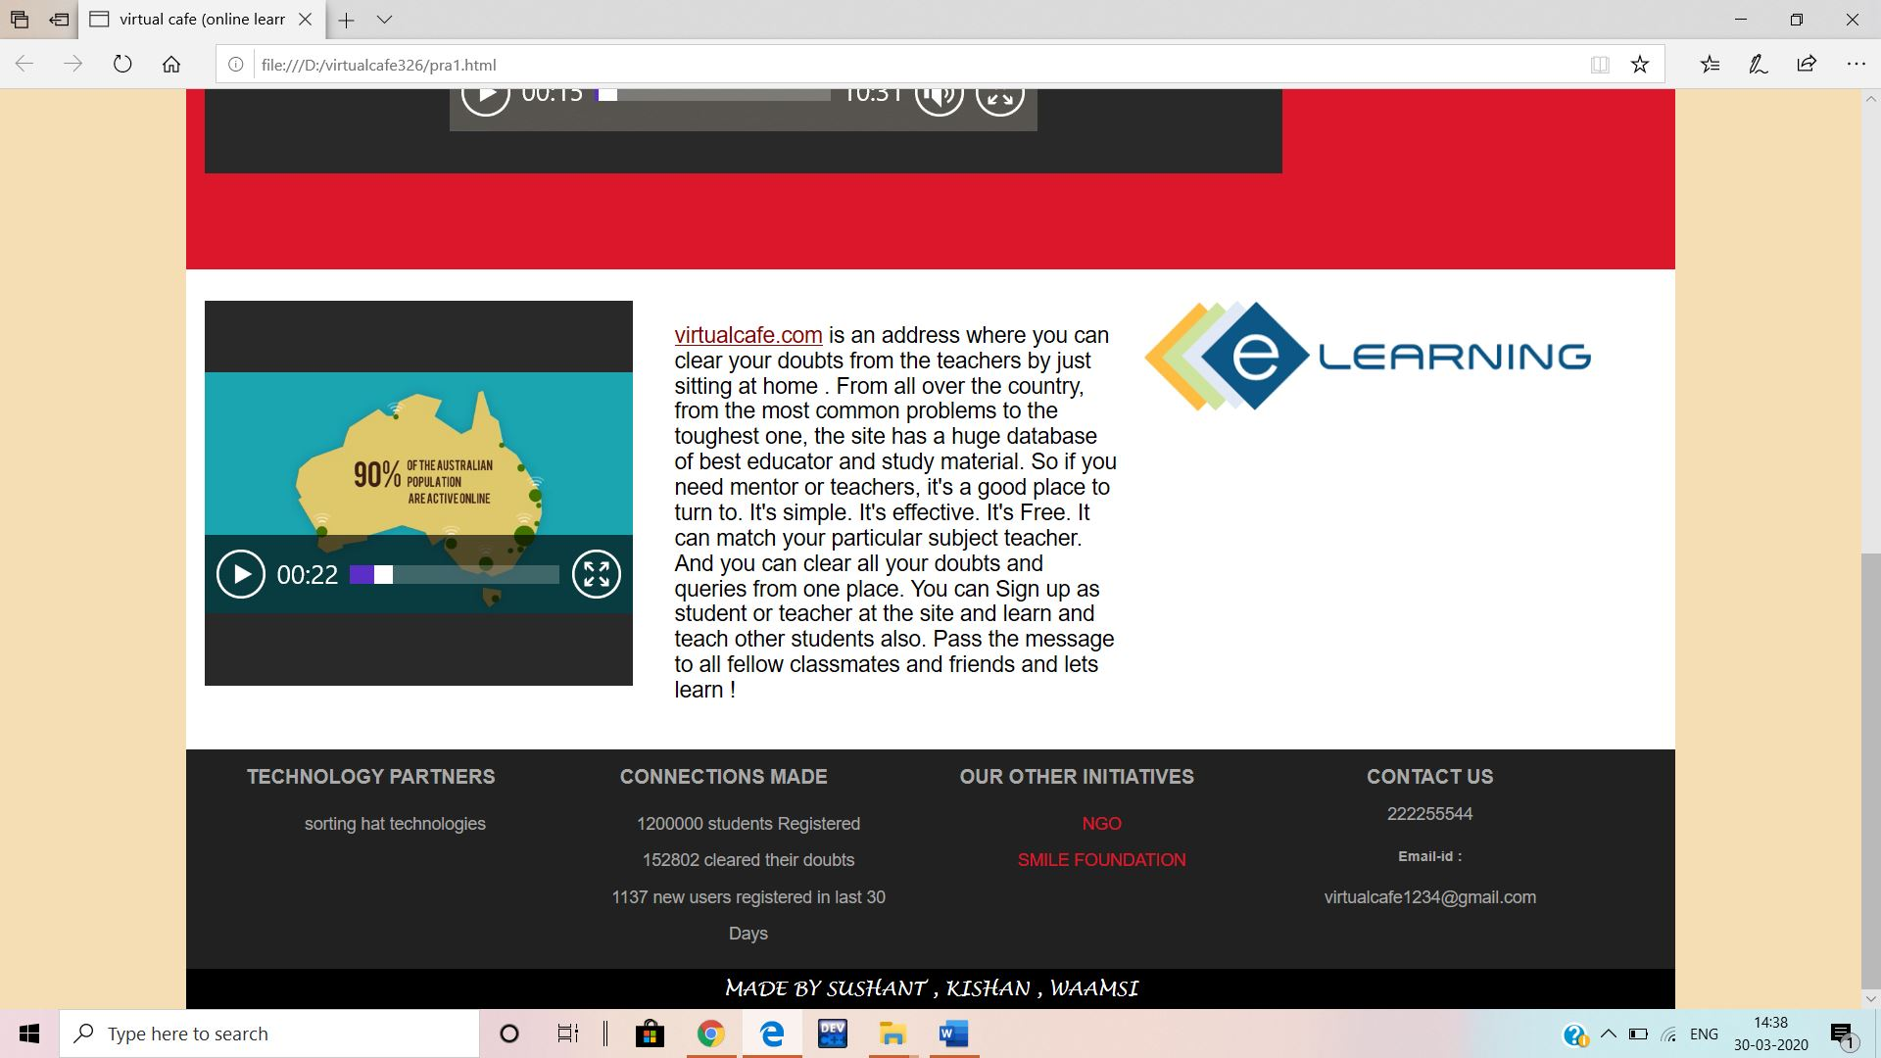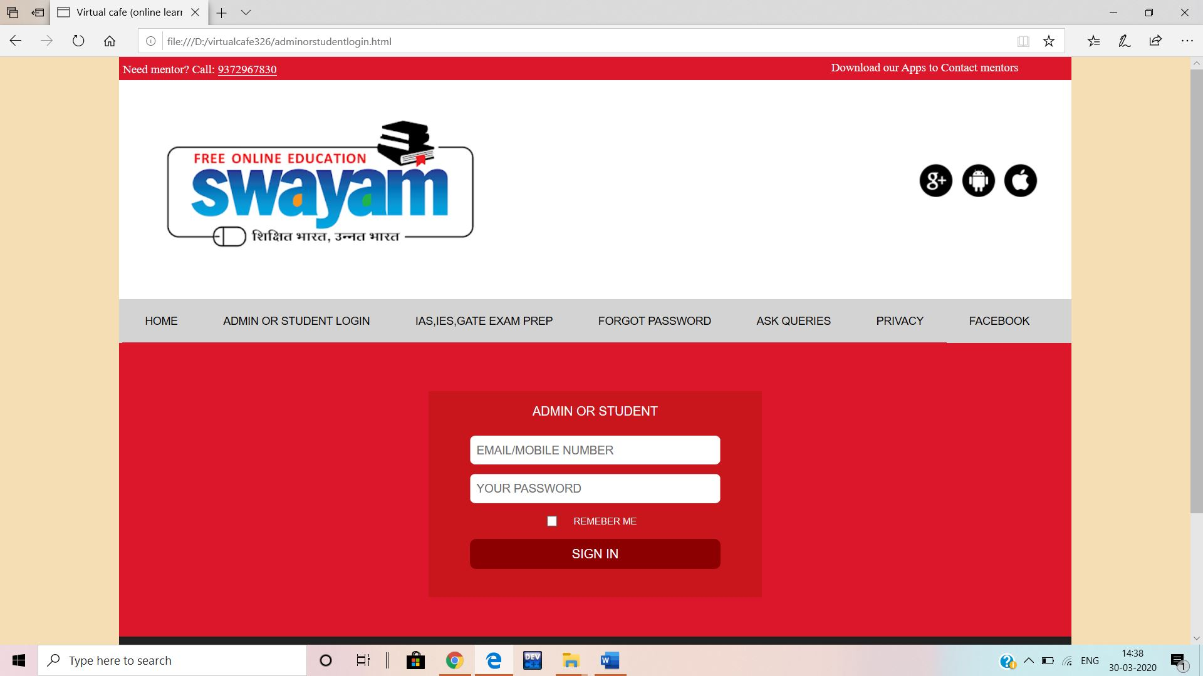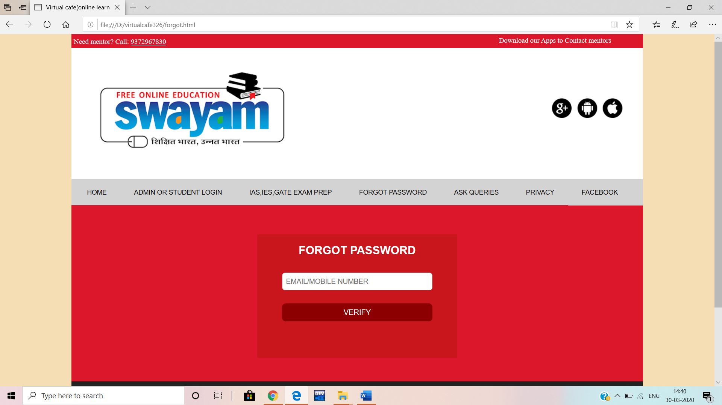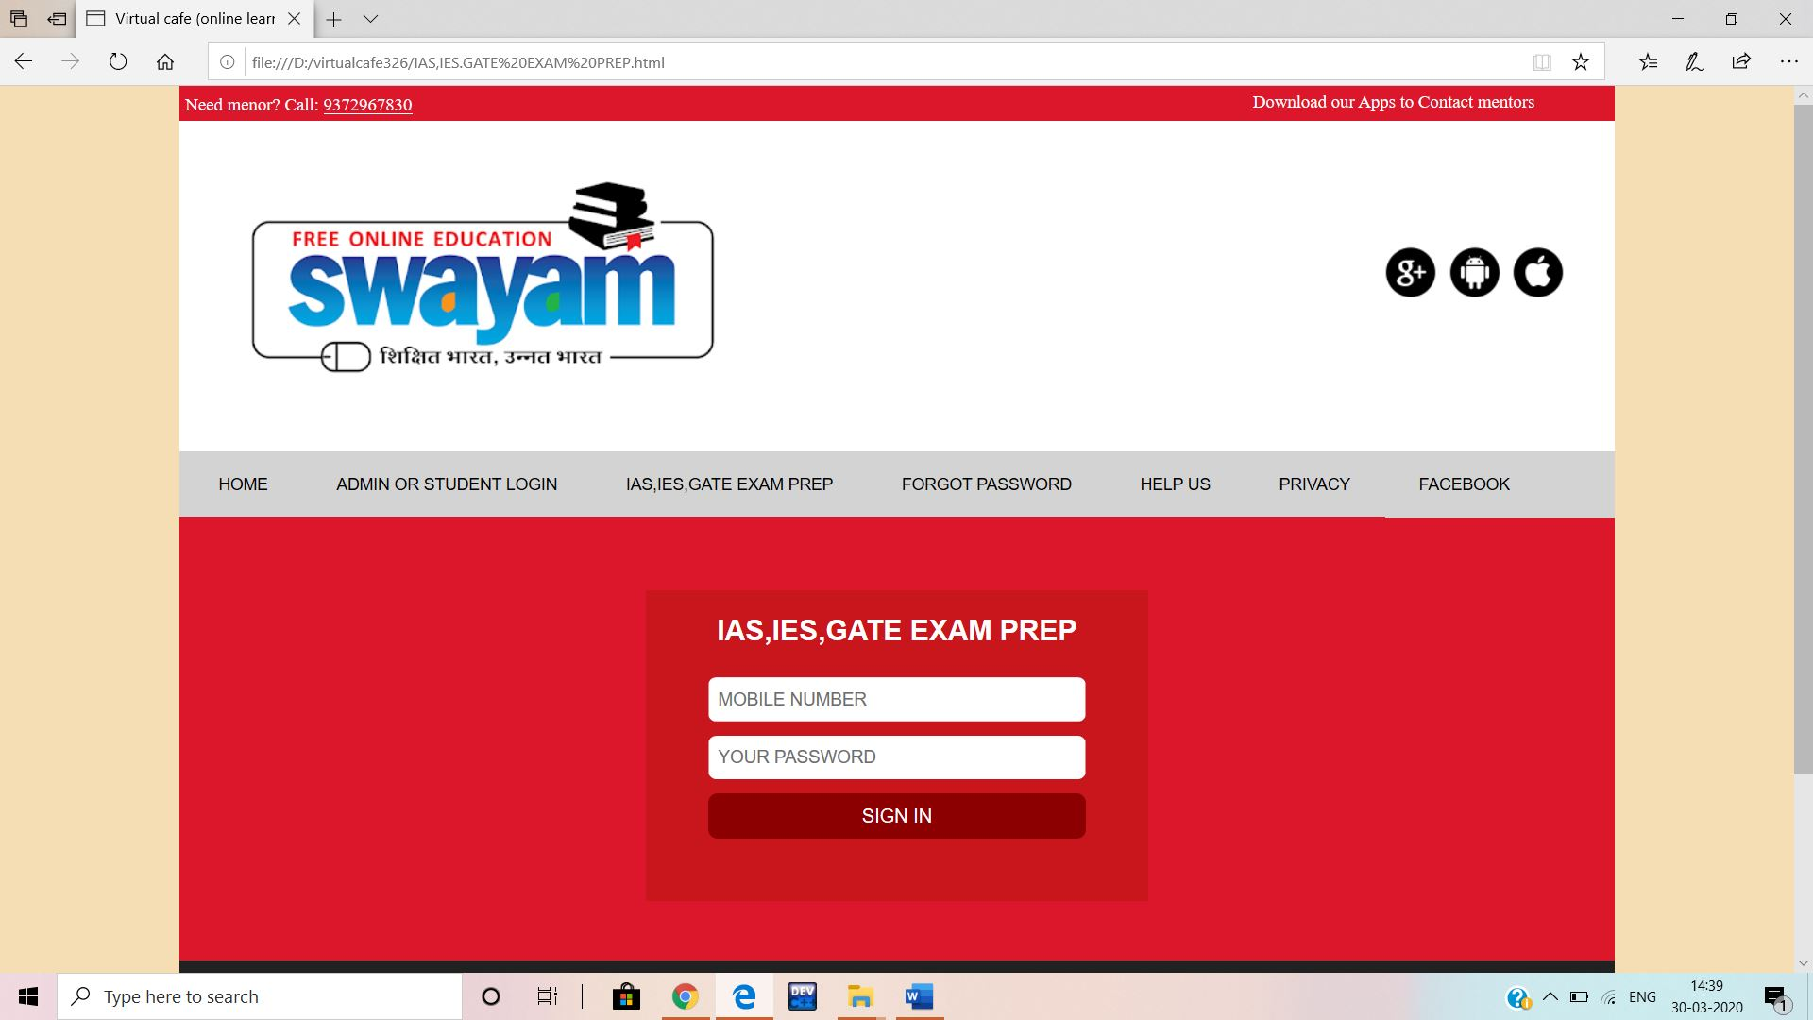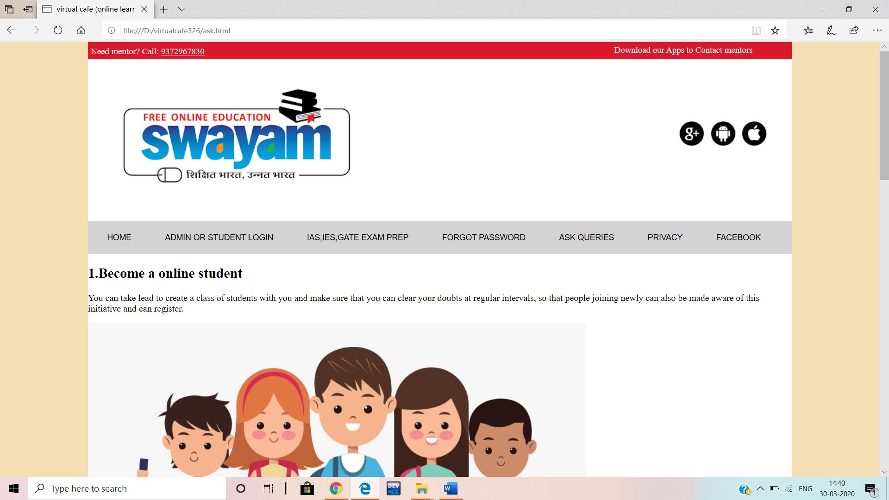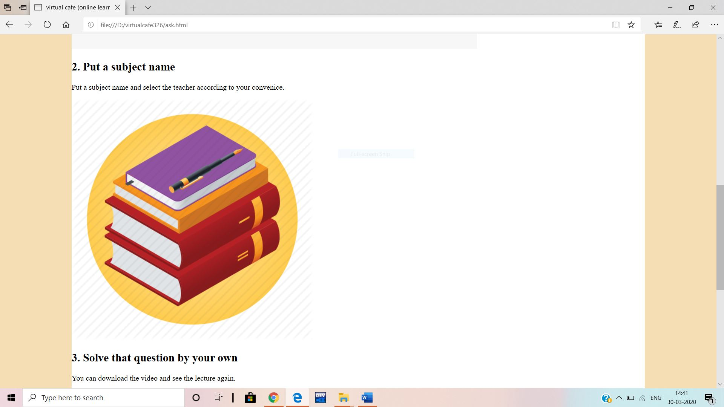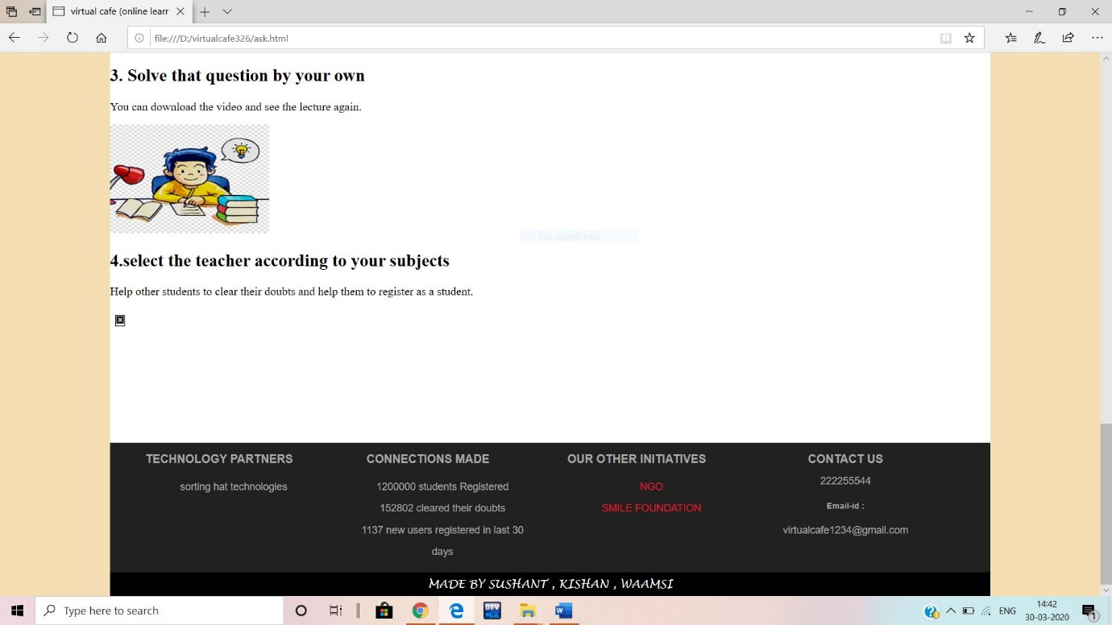 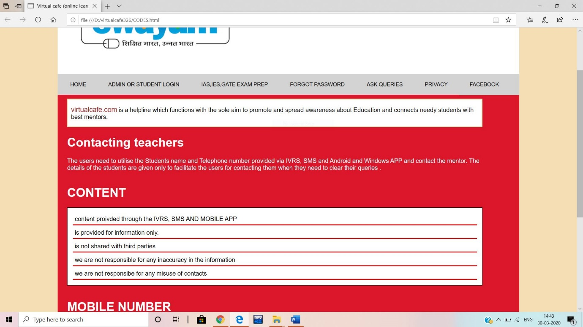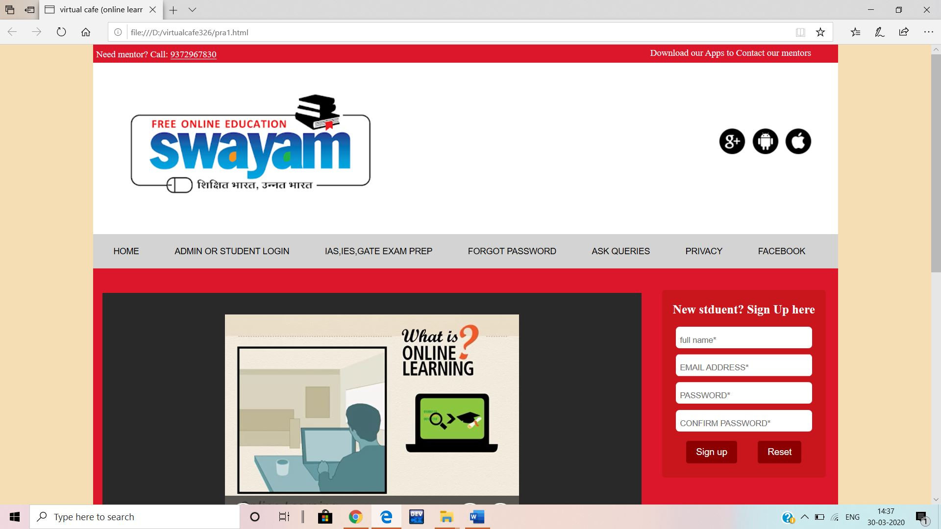

MY CONTRIBUTION

NAME: MIDDULA VAMSI (11903311)

This project is mainly towards students who are willing to do study and learn new concepts from the available educators.

Through this website students can find out the right educator for their subject and it will become easy to build the connection between the educators and educational authorities.

The main intend of this project is that effective learning requires access to social and academic networks for both study material and emotional support.

IAS, IES, GATE Preparation:

In this module students will be able to choose for what exams are they preparing like entrance, government exams and engineering exams like GATE.

In this module you can select the exam for which you want to prepare in that you can select test, exam, and test preparation.



MY CONTRIBUTION

NAME: KISHAN KUMAR SINGH (11903288)

This project is mainly towards students who are willing to do study and learn new concepts from the available educators.

Through this website students can find out the right educator for their subject and it will become easy to build the connection between the educators and educational authorities.

The main intend of this project is that effective learning requires access to social and academic networks for both study material and emotional support.

STUDENT OR ADMIN LOGIN:

In this section, a user can login to his account with the help of user Id and password to share and update information like age, location, last learning hours, contact number and he/she can post their queries.in this user can login as Admin, teacher, student.

SIGN UP:

In this module user who login’s have to first registered on our website and give his/her overall details related to him i.e. he fills in a registration such as contact number, email address etc and after that they can login to our website.

MY CONTRIBUTION

NAME: SUSHANT KALIKAPRASAD PAL (11903319)

This project is mainly towards students who are willing to do study and learn new concepts from the available educators.

Through this website students can find out the right educator for their subject and it will become easy to build the connection between the educators and educational authorities.

The main intend of this project is that effective learning requires access to social and academic networks for both study material and emotional support

Description:

Online Education website is to provide services to students who are in need of proper educator for their subjects by getting help from the educator that are available to them.

CONTACT US:

Through the contact section students can communicate with virtual cafe admin panel if they are facing any problem with their account

**PRIVACY:**

Through this module students or user will came to know the terms and conditions of virtualcafe.com its privacy and reserve rights and it is not responsible for any kind of misuse of details.